Three insights of Data: LinkedIn Top Skills for 2016
LinkedIn made public their survey that on their site what are the most preferred skills that the employers searching by countries. The dataset shows the skill’s ranking by each field, broken down by several countries. From that dashboard, I took 3 examples.
1, Blue and Green dots in the dashboard
The first thing you can find is there the 14 participant countries and 10 most preferred that the employers need from the candidates.

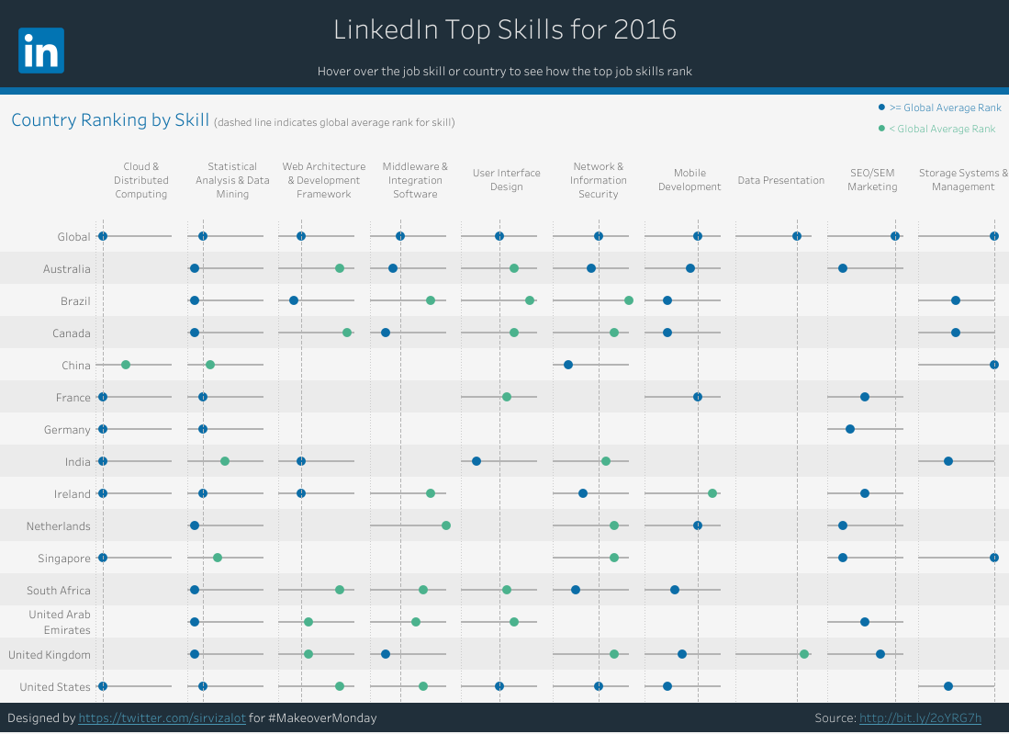

The Blue dots show us the skills are more valuable in the Global Average Rank than average, and the Green dots show us the opposite this, so it’s less valuable in the Global Average Rank than average. With this table, you can check what skills you need to get a better chance of finding a better job in your country.

Finally, there is a table from that each of this countries how many Blue or Green dots have from the 10 skills category.

Country | Blue Dot | Green Dot | Empty | Country | Blue Dot | Green Dot | Empty
Australia | 5 | 2 | 3 | Ireland | 5 | 2 | 3
Brazil | 4 | 3 | 3 | Netherlands | 3 | 2 | 5
Canada | 4 | 3 | 3 | Singapore | 3 | 2 | 5
China | 2 | 2 | 6 | South Africa | 3 | 3 | 4
France | 4 | 1 | 5 | United Arab Emirates | 2 | 3 | 5
Germany | 3 | 0 | 7 | United Kingdom | 4 | 3 | 3
India | 4 | 2 | 4 | United States | 6 | 2 | 2

As you can see, the United States has the largest number from Blue dots; and Brazil, Canada, South Africa, United Arab Emirates, and the United Kingdom have a same with 3 Green Dots.

I think the result shows the fact, why the United States has the biggest technological power on the planet. Just think a few of biggest IT / technological company, like Amazon.com, Facebook, Ford, IBM, or Ford. They move in a lot of fields, like Cloud & Distributed Computing, Statistical Analysis & Data Mining, or Mobile Development. My assumption is these companies focus the Big Data platform, Cloud Technologies, Machine Learning, Artificial Intelligence, Mobile Development, and Financial Analysis.

2, Global part of the table and Statistical Analysis & Data Mining
After I clicked on the Global part of the table that showed me that top 10 skills in the selected 14 countries:

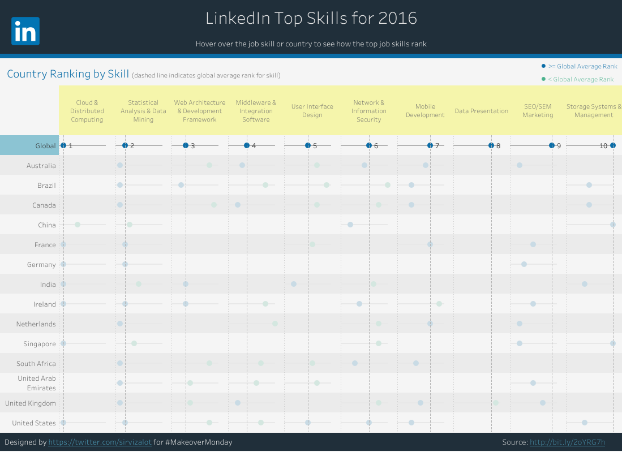

You can see that the skills that contact with data get to become more important, like, data mining, data presentation, and statistical analysis.

After that, I clicked to “Statistical Analysis & Data Mining”. It’s a little trick, but on the dashboard, you can view more than one point with CTRL + click. I choose this category because there every country has a Blue or Green Dot.

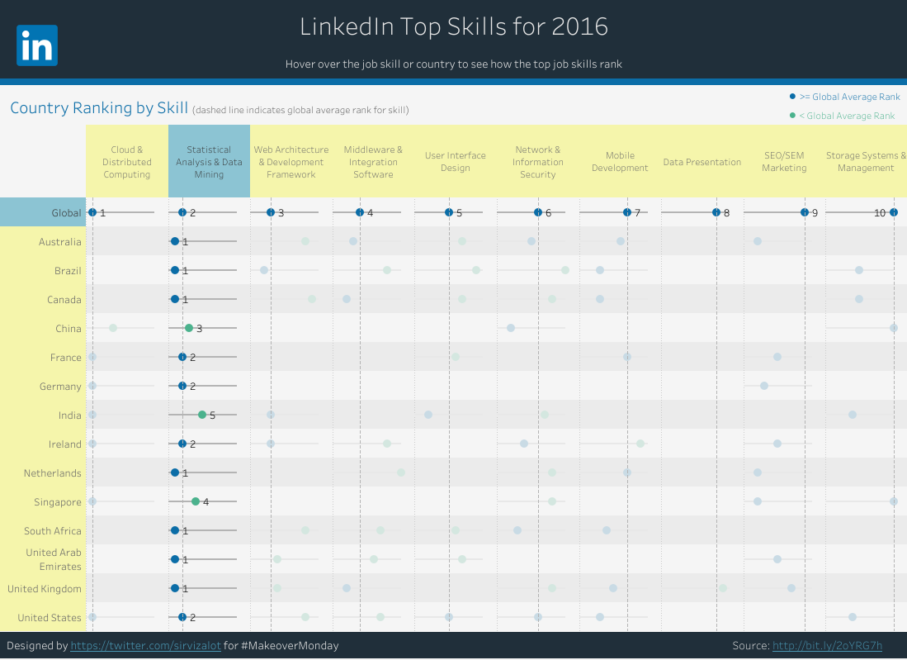

As you see only China, India and Singapore were under the Global Average Rank, in the others this skill was more valuable than the average.
3. Data Presentation Skill

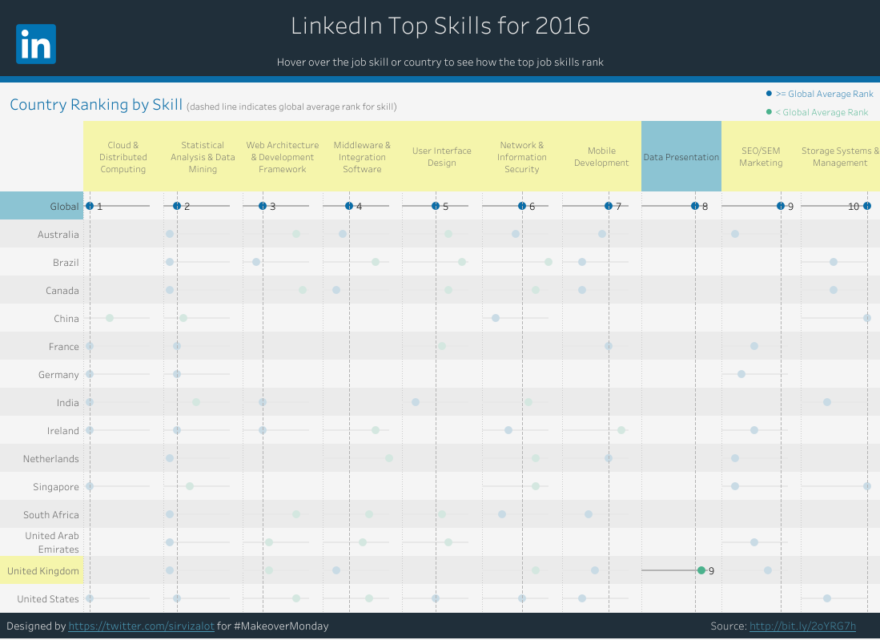

I choose “Data Presentation” skill because it’s strange for me when I only see this in the United Kingdom. This is ninth skill from ten, and globally the eight of ten. I think because in this fields Data Presentation skill needs to be a generic one. You must know how to present/show your work to your clients, or co-workers, and how to briefly summarize it. You need to know, how can you speak in a short or long way, from your work processes, your product or anything that is related to you or your skills. And I think this skill needed for the job interviews to when you need to speak yourself and show your best.

